Homework 2

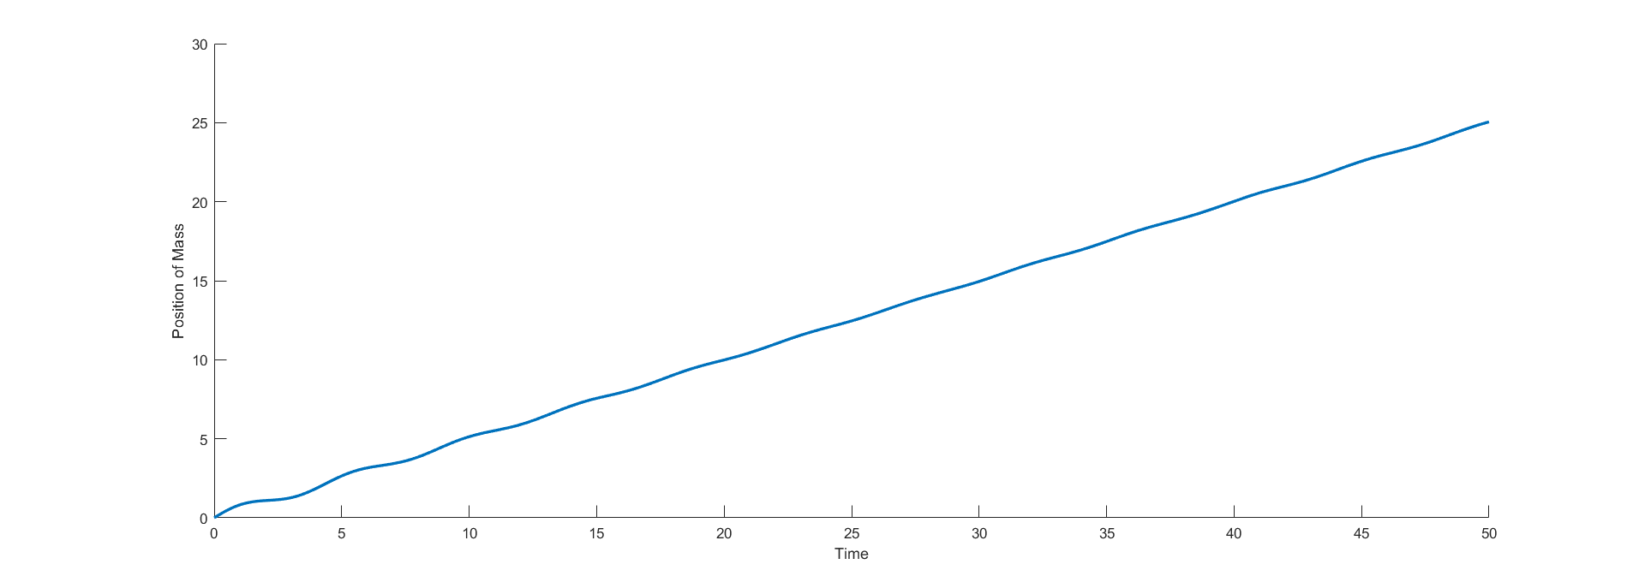

Fig1: Plot of Mass M velocity. The plot makes sense because the dumping is 10-time smaller dans the spring constant. As the mass make through the small resistance of the dumper, it velocity goes linearly.

Fig2: Plot of Mass M velocity. The plot makes sense because the dumping smaller than the spring constant. As the mass get to terminal velocity but takes long time with velocity getting closer to 10.

Fig3: Plot of Mass M velocity. The plot makes sense because the dumping is greater than the spring constant. The mass gets to terminal velocity but faster and a velocity smaller than the fig2.

Fig4: Plot position of double pendulums angle 1 and 2. The angles are out of phase. The angle 1 in blue and angle 2 in red

Fig: below is the simulation using Simulink. The angle is in degrees

